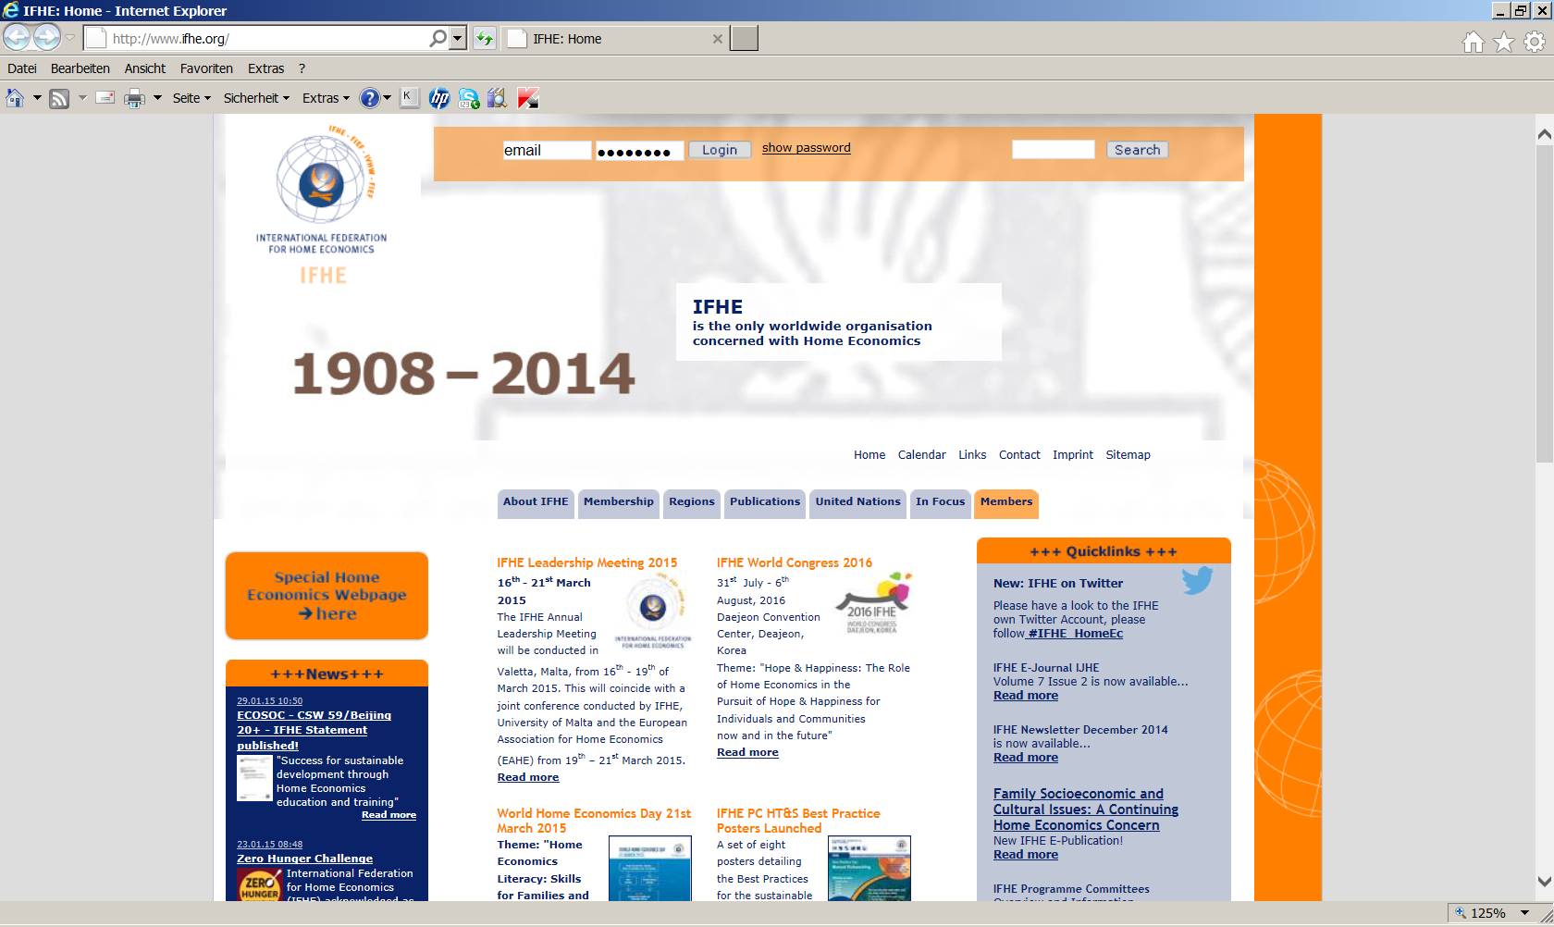

The password can be found in the IFHE Memberdatabase

1. Enter your e-mail address
2. Click on “Forgot Password”

**(**[**www.ifhe.org/ifhem**](http://www.ifhe.org/ifhem)**)**

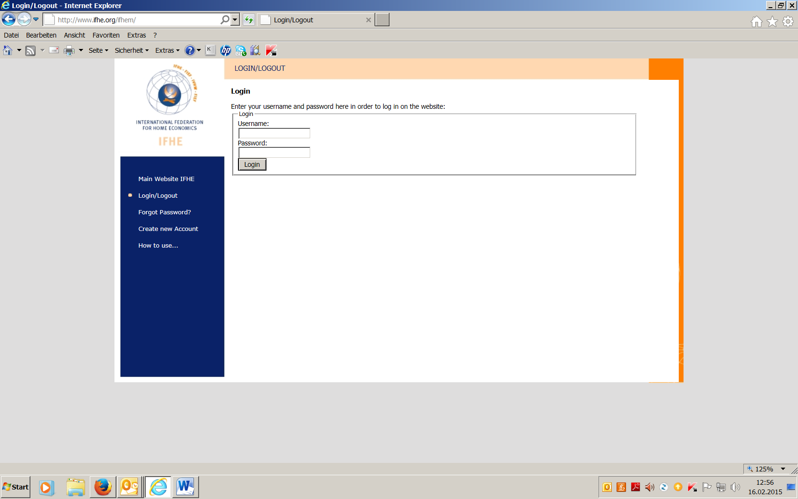

1. Password will be sent to your e-mail address

**Access to the members only area**

Please enter your

1. **e-mail address**

and

1. **Password**
2. **Click on login**
3. **Click on orange members**
4. **See different sections in the left column**

(